📄 REPORT: Enhanced Long Sequence Handling in BERT

Using Sliding Window and Attention-Based Pooling

1. Abstract
This report addresses the long sequence limitation of BERT, which can process a maximum of 512 tokens per input. To overcome this issue for long IMDb movie reviews, a sliding window chunking approach was implemented. Three chunk aggregation techniques—mean pooling, max pooling, and a proposed attention-based pooling mechanism—were compared. Experimental results show that the attention-based method achieves the best performance in terms of accuracy and F1 score.

2. Introduction
BERT is one of the most widely used transformer-based models in Natural Language Processing for tasks such as sentiment analysis, text classification, and question answering.
However, a key limitation of BERT is:
Maximum input length=512Maximum input length=512
Maximum input length=512Maximum input length=512
For long reviews, truncation may remove important contextual information and sentiment-rich words.
The objective of this work is to handle long documents more effectively using sliding window tokenization and advanced chunk aggregation methods.
For reproducibility and further reference, the complete implementation notebook and experimental code have been made available in the GitHub repository: https://github.com/yourusername/bert-long-sequence-attention

3. Problem Statement
The standard BERT architecture is restricted to 512 tokens. When long reviews exceed this limit, direct truncation may lead to loss of crucial sentiment-bearing words.
For example, the positive sentiment word may appear at the end of a long review, which would be ignored by truncation.
Hence, a method is required to process the full document without losing information.

4. Dataset Used
The IMDb movie review dataset was used for binary sentiment classification.
The dataset contains:
- 50,000 reviews
- positive and negative sentiment labels
For efficient experimentation, a randomized subset of 2000 samples was selected.
Split used:
- Training = 1600
- Testing = 400

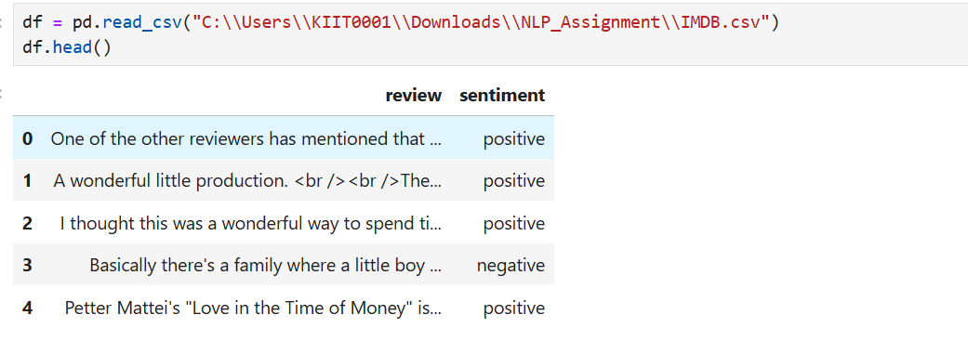
Figure 1: Initial preview of the IMDb dataset showing review text and sentiment labels.

5. Data Preprocessing
The sentiment column was converted into binary labels:
- positive = 1
- negative = 0
This binary representation is suitable for sentiment classification.
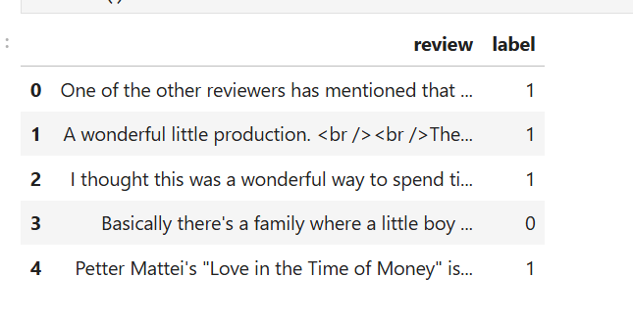
Figure 2: Dataset after preprocessing and label encoding.

6. Methodology

6.1 Sliding Window Tokenization
Long reviews were divided into overlapping chunks of maximum 512 tokens.
Example:
Chunk 1: tokens 1–512
Chunk 2: tokens 383–894
Chunk 3: tokens 766–1278
This preserves context while handling long inputs.

6.2 Pooling Methods
Three methods were implemented.

A) Mean Pooling
𝐷𝑜𝑐=1𝑛∑𝑖=1𝑛ℎ𝑖Doc=n1​i=1∑n​hi​
𝐷𝑜𝑐=1𝑛∑𝑖=1𝑛ℎ𝑖Doc=n1​∑i=1n​hi​

B) Max Pooling
𝐷𝑜𝑐=max⁡(ℎ1,ℎ2,...,ℎ𝑛)Doc=max(h1​,h2​,...,hn​)
𝐷𝑜𝑐=max⁡(ℎ1,ℎ2,…,ℎ𝑛)Doc=max(h1​,h2​,…,hn​)

C) Proposed Attention Pooling
𝐷𝑜𝑐=∑𝑖=1𝑛𝛼𝑖ℎ𝑖Doc=i=1∑n​αi​hi​
𝐷𝑜𝑐=∑𝑖=1𝑛𝛼𝑖ℎ𝑖Doc=∑i=1n​αi​hi​
This is the unique contribution of the work.
The model learns the importance of each chunk.

7. Experimental Results
The following performance metrics were recorded:
- Accuracy
- F1 Score
- Training Time
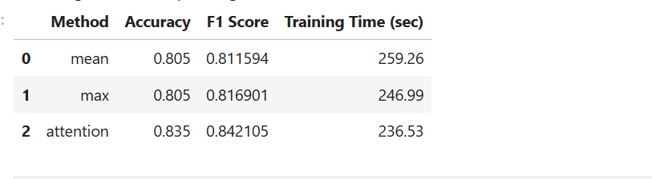
Figure 3: Comparative performance of mean, max, and attention pooling methods.
Table 1 — Results Summary
Method | Accuracy | F1 Score | Training Time
Mean Pooling | 0.805 | 0.8116 | 259.26 sec
Max Pooling | 0.805 | 0.8169 | 246.99 sec
Attention Pooling | 0.835 | 0.8421 | 236.53 sec

8. Final Evaluation on Larger Data
The best-performing method (attention pooling) was further evaluated on a larger subset.
Results obtained:
- Accuracy = 0.7825
- F1 Score = 0.7629
- Time = 1009.4 sec
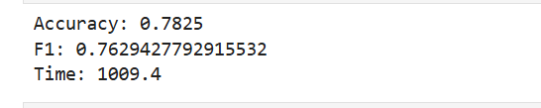
Figure 4: Final performance of attention pooling on larger training data.

9. Observation
The experimental results indicate that the proposed attention pooling method performs better than the traditional mean and max pooling techniques for long sequence sentiment analysis.
From the comparison, both mean and max pooling achieved an accuracy of 0.805, whereas attention pooling achieved the highest accuracy of 0.835 along with the best F1 score of 0.8421.
This shows that attention-based aggregation is more effective in identifying and focusing on the most sentiment-rich chunks of a long review. Unlike mean pooling, which gives equal importance to all chunks, attention pooling assigns different weights based on the importance of each chunk.
As a result, the model is able to capture stronger contextual and sentiment information from long documents.
Another observation is that the attention method also required slightly lower training time compared to the other pooling methods, making it both efficient and accurate.
Overall, the results clearly suggest that attention pooling is the most suitable method among the three tested approaches.
10. Conclusion
In this work, the 512-token limitation of BERT was addressed using a sliding window approach for long reviews.
Among the three pooling methods tested, attention pooling achieved the best performance in terms of accuracy and F1 score.
The results show that assigning learned importance to each chunk improves long-document representation and sentiment classification.
Thus, the proposed method provides an effective solution for handling long text inputs in BERT-based sentiment analysis.

